PhD Viva Voce
Candidate Name: | Silvani Dismas | 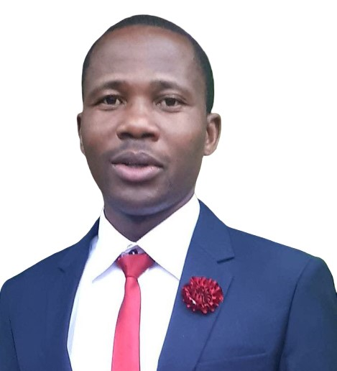
Registration Number: | 2020-07-00162
 | University of Dar es Salaam
 | School of Education

Qualifications Attained:
Mr. Dismas is a PhD candidate by Coursework and Dissertation in the Department of Educational Psychology and Curriculum Studies (EPCS), School of Education at the University of Dar es Salaam (UDSM). In 2017, he obtained a Master degree (Curriculum and Instruction) from the University of Arusha, and Post Graduate Diploma in Education in 2013 from the same University. In 2011, he attained a Bachelor of Arts in Political Science and Public Administration (PS&PA) from the University of Dar es Salaam. His professional experience entails classroom teaching and educational administration. His research interests include curriculum studies, educational technology, educational administration, comparative/international education, gender and development in education, organization and management issues.

Title of Thesis: | An Investigation of District School Quality Assurance Officers’ Understanding and Practices of Competence-Based Curriculum in Tanzania
Date of Viva Voce: | 18th April, 2024
Venue: | Board Room-SoED
Time: | 10:00a.m
Supervisors: | Dr. Ibrahimu Nzima & Dr. Aurelia Kimaro

Abstract:
This study investigated district school quality assurance officers’ understanding and practices of the competence-based curriculum (CBC) in Tanzania. Specifically, the study had four research objectives. Firstly, to investigate how district school quality assurance officers (DSQAOs) understand CBC. Secondly, to investigate how DSQAOs conduct CBC quality assurance in secondary schools. Thirdly, to explore the setbacks against DSQAOs’ conduct of CBC quality assurance in secondary schools, and fourthly, to investigate the ways for effective DSQAOs’ CBC quality assurance in secondary schools. The study was guided by an interpretive paradigm and conducted under qualitative research approach; and utilised a case study design. It involved a total of 40 participants who were purposively and conveniently selected. Categorically, the sample included 12 DSQAOs, four heads of school and 24 teachers. Data generation methods were semi-structured interviews, participant-assisted drawings, observations, and documentary review. Data were subjected to thematic analysis and presented in the form of narrative, figures, and tables. Findings revealed the following. First, DSQAOs had varied understandings of CBC such as CBC as a curriculum that supported students’ studies and learning environment; CBC as a curriculum that supported students’ acquisition of competences needed in their daily life; while others failed to explain its meaning. Second, the study had shown that DSQAOs prepared for SQA and informed heads of school before school visit. During the visits, they conducted classroom observations and give feedbacks for improving teaching and learning activities in schools. However; DSQAOs’ use of harsh language to teachers, limited time during school visit, inadequate report writing, and lack of clear conceptualization of CBC concepts hindered effective support to teachers. Third, the identified drawbacks against DSQAOs’ effective CBC quality assurance included the absence of CBC quality assurance guideline, limited knowledge on CBC, insufficient time for CBC related activities during school visits, and unfriendly teacher-DSAQOs’ relationship. Fourth, the findings proposed an effective DSQAOs’ CBC quality assurance framework which accommodated aspects of independent school quality assurance body, proper DSQAOs’ recruitment and CBC orientation, accessible CBC quality assurance guideline, collaborative DSQAOs-teacher relationship and equitable time during school visit and sufficient resources as well as an effective collaboration between government and non-government actors. The study concluded that majority of DSQAOs had limited understanding of CBC, something that impacted their CBC quality assurance practices. Hence, for effective CBC quality assurance; proper recruitment of DSQAOs and regular CBC orientations are imperative. The study recommended for the MoEST in collaboration with TIE and other stakeholders to ensure proper DSQAOs’ recruitment and CBC orientation (trainings, seminars, and workshops) among DSQAOs as well as using this study’s devised CBC quality assurance framework in secondary schools in Tanzania.

Panel Members
No | Name | Designation | Rank | Unit
 | Prof. Abel Ishumi | Chairperson | Professor Emeritus | SoED-EFMLL
 | Dr. Mwajuma Vuzo | Representing External Examiner | S/Lecturer | SoED-EPCS
 | Dr. Eugenia Kafanabo | Internal Examiner | S/Lecturer | SoED-EPCS
 | Dr. Ibrahim Nzima | Candidate’s Supervisor | Lecturer | SoED-EPCS
 | Dr. Albert Tarmo | Head of the relevant department (or his/her appointee) | S/Lecturer | SoED-EPCS
 | Dr. Wadrine Maro | Co-opted Member (appointed by College/School/Institute | Lecturer | SoED-EPCS
 | Dr. Fortunatha Matiba | Co-opted Member (appointed by College/School/Institute | S/Lecturer | SoED-EFMLL
 | Dr. Josta Nzilano | Appointee of the Principal for PhD only) | Lecturer | DUCE-EPCS

